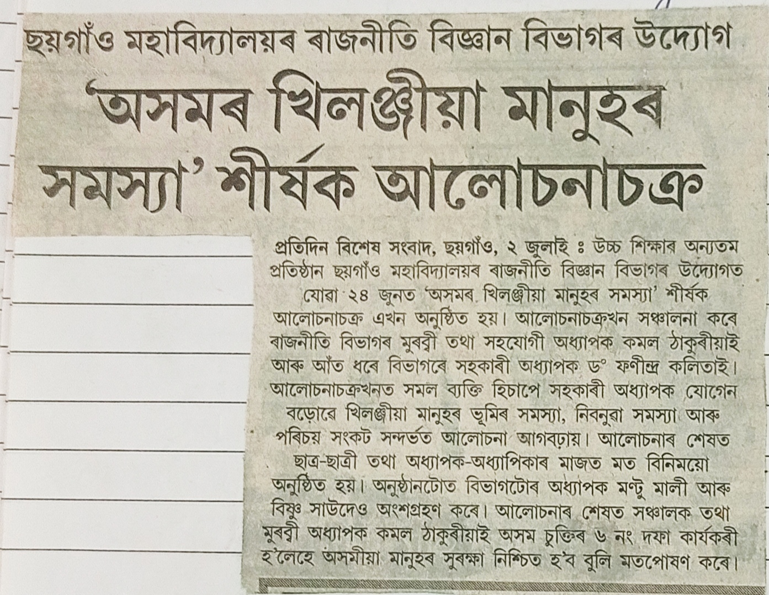
A Departmental Seminar Organized by the Political Science Department in the local Leading News Paper, “Pratidin”.
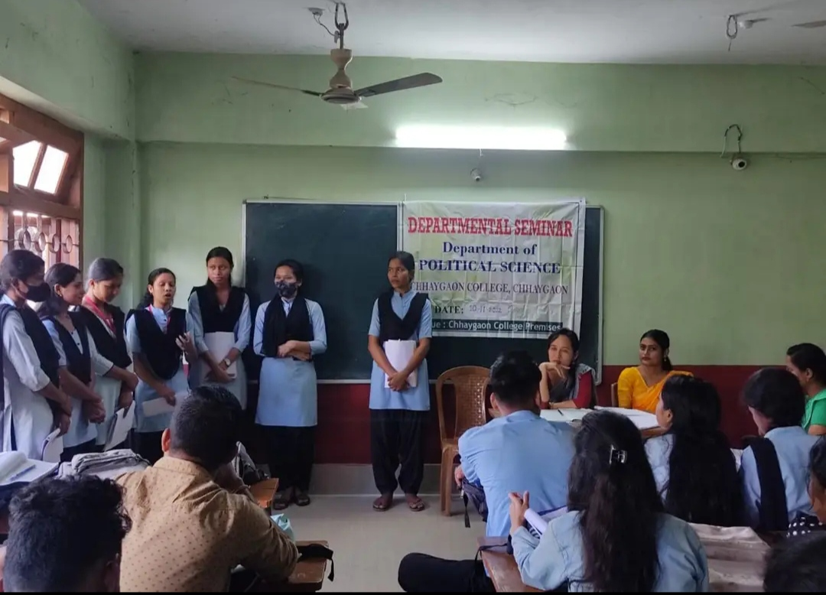
A Departmental Seminar on the topic ‘’Classical Political Philosophy” was organized on 10/11/2022 by the Department of Political science, Chhaygaon College, Chhaygaon.

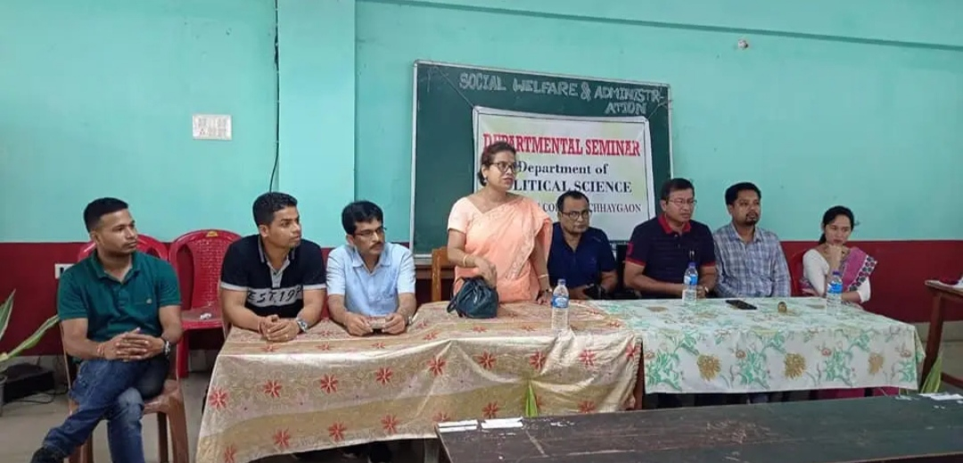
A Departmental Seminar on the topic ‘Social welfare and Administration” was organized on 18/08/2022 by the Department of Political Science, Chhaygaon College, Chhaygaon.

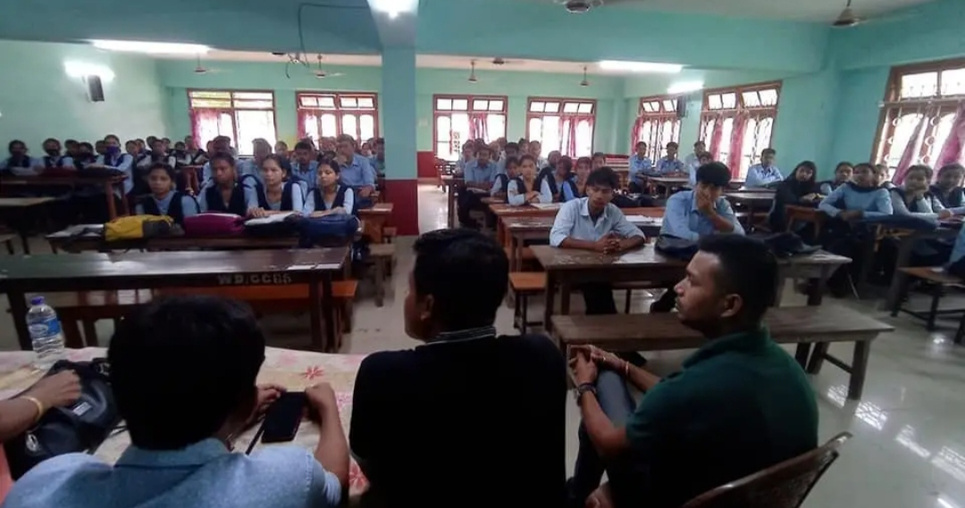
A scene from the Departmental Seminar on the topic ‘Social welfare and Administration” was organized on 18/08/2022 by the Department of Political Science, Chhaygaon College, Chhaygaon.

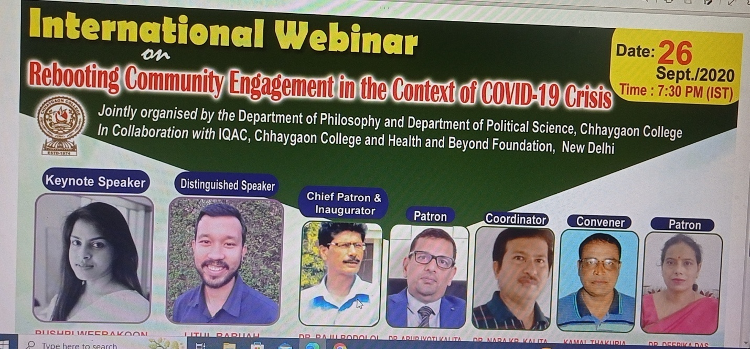

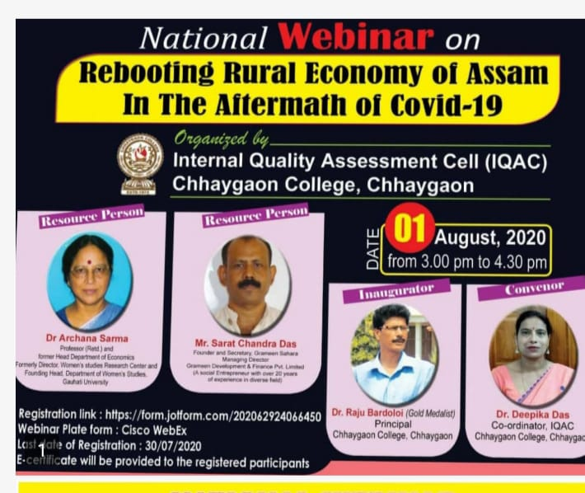

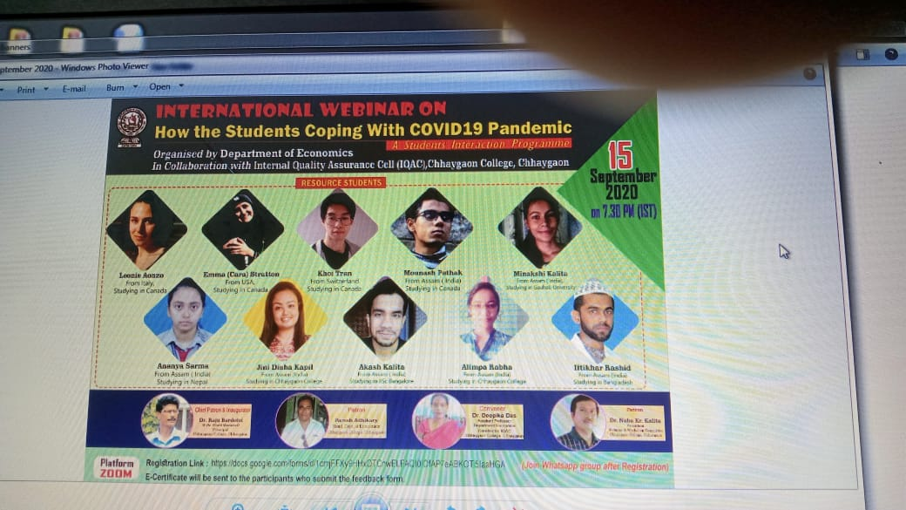

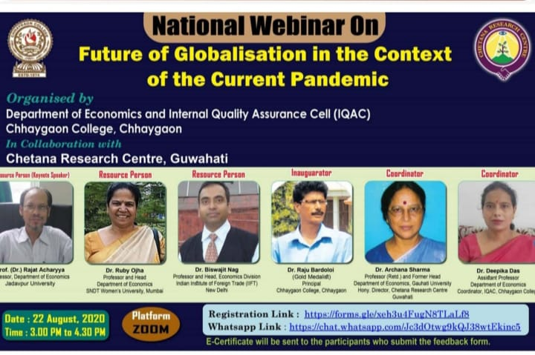

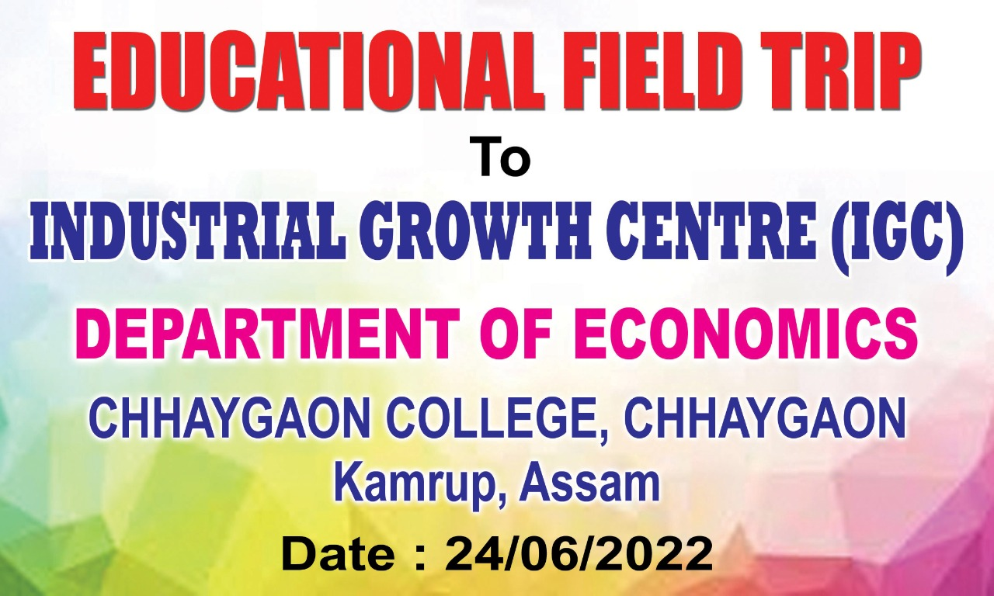

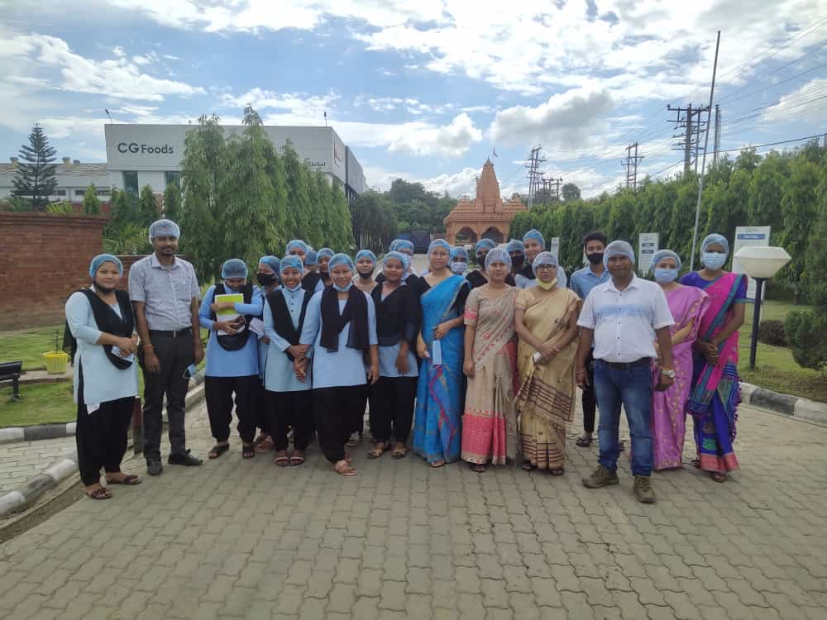
Educational Field trip to Industrial Growth Centre (IGC) by the Department of Economics on 24/06/2022.

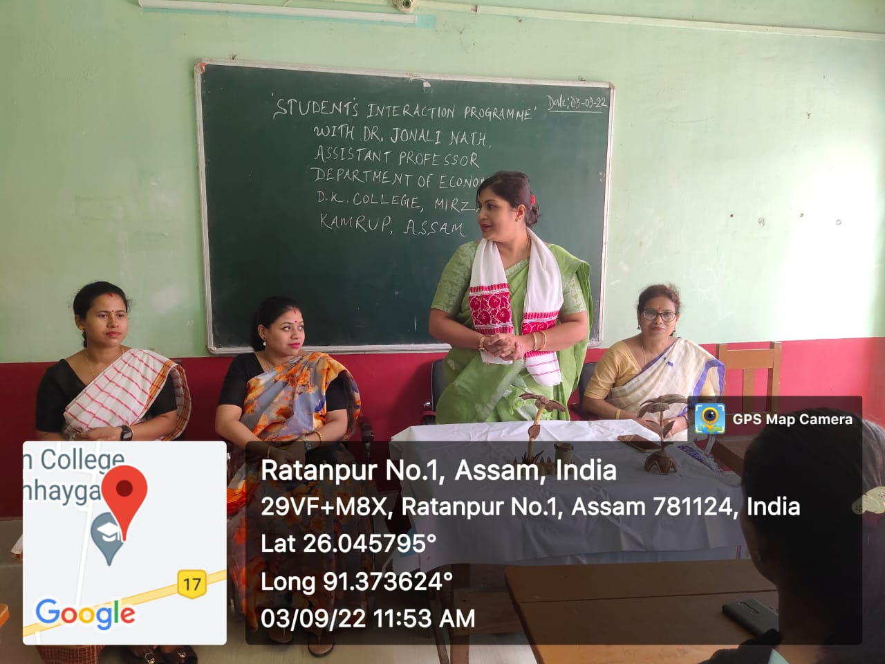

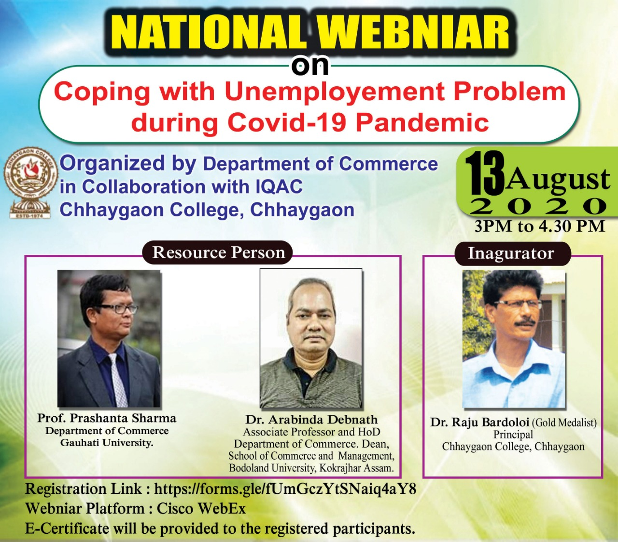

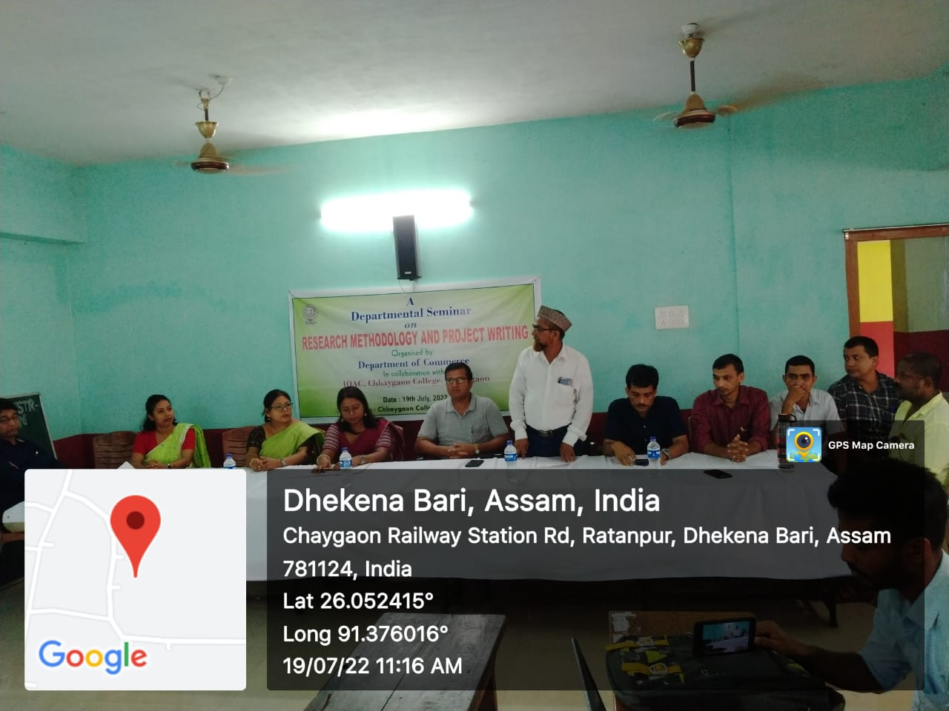

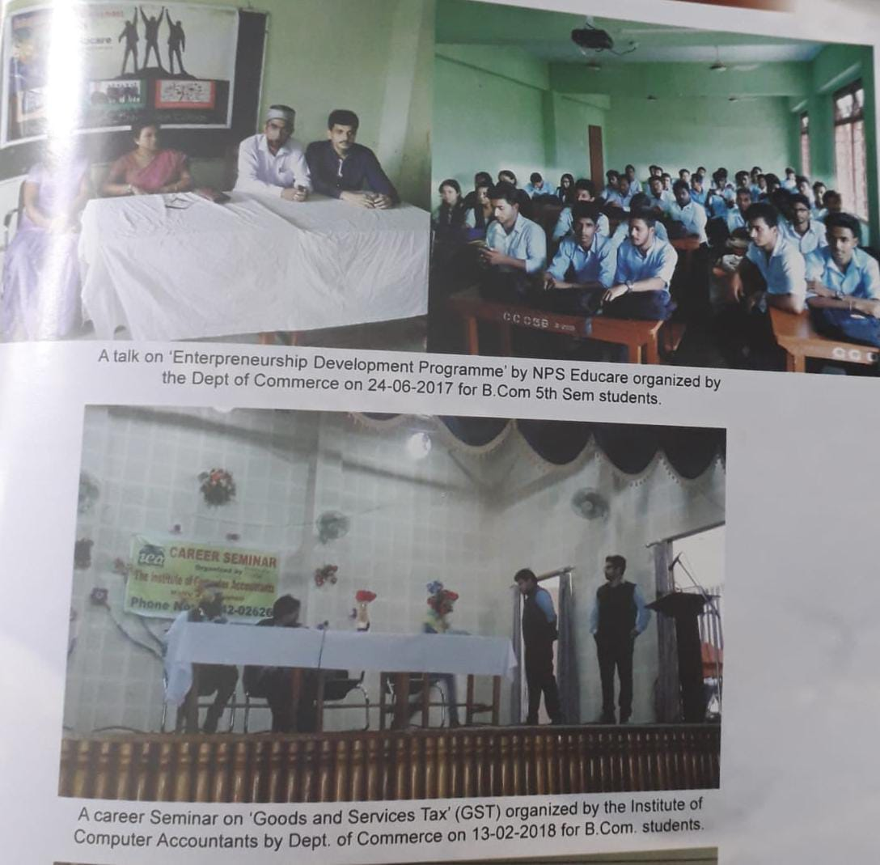

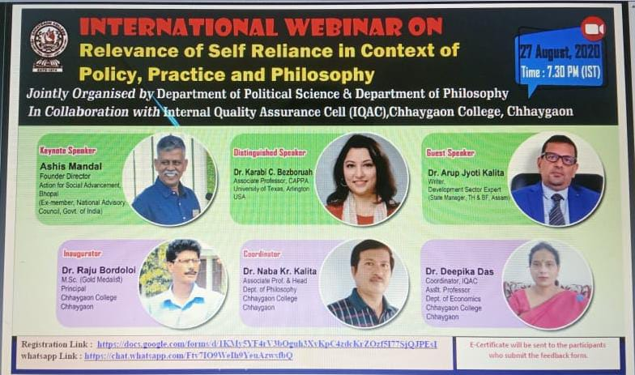

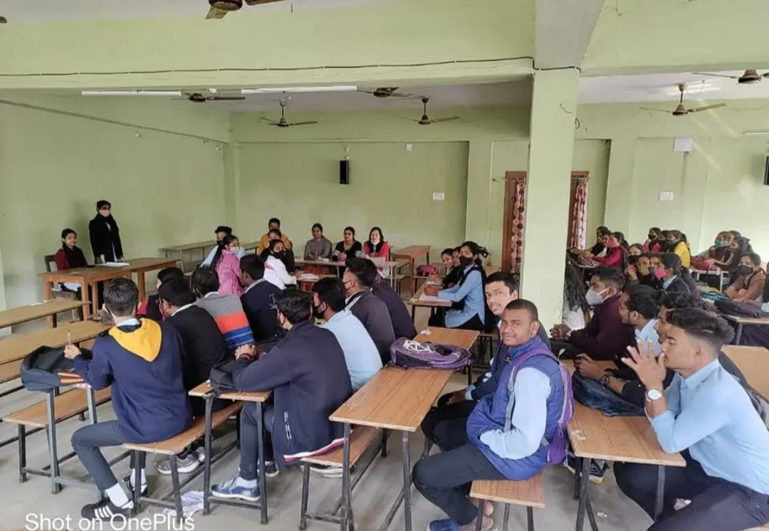
Practiced Mock Parliament as a part of Skill education of B.A. 3rd Semester of Political Science, Chhaygaon College, Chhaygaon on 11th February, 2022.

