7.Quality initiatives by IQAC during the year( 2018-2019) for promoting quality culture
Environmental Day Celebration- 5th june 2018:
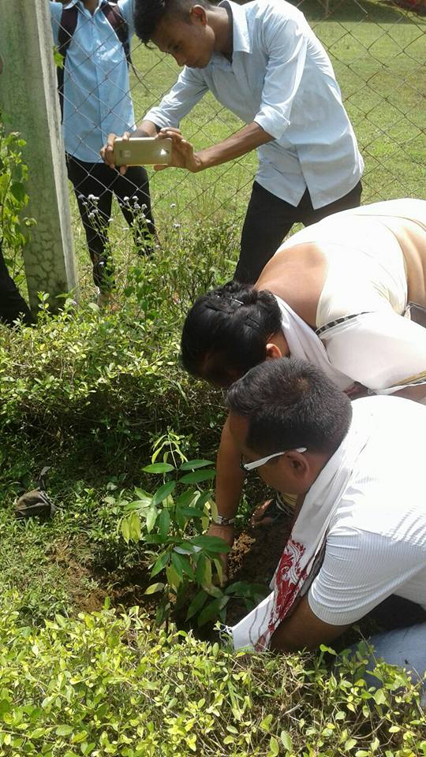
International Yoga Day celebration- 21 june 2018:
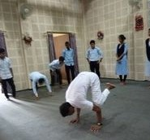

Felicitation programme (Student achievement) in collaboration with Chhaygaon Anchalik Student Union:

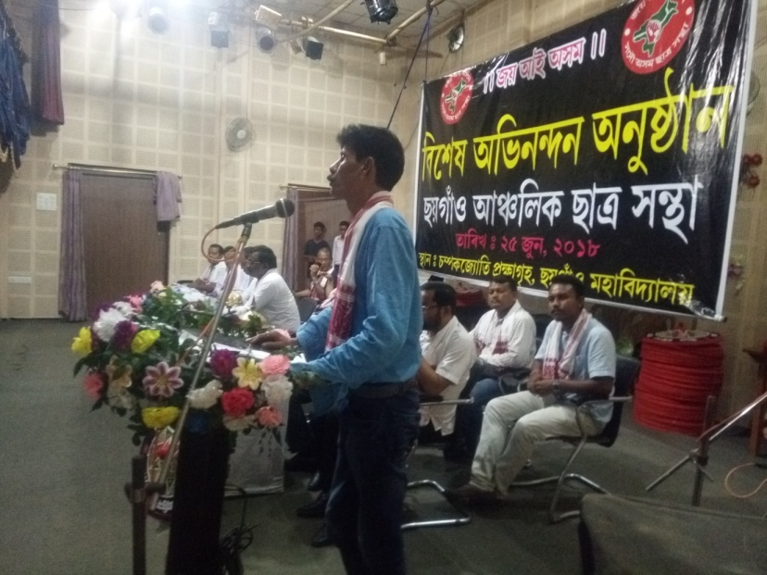

Enactment of Drama by student and teacher Jointly organized by Chhaygaon college Student:



A talk on how to prepare for Competitive Examination: 5th Sept 2018:
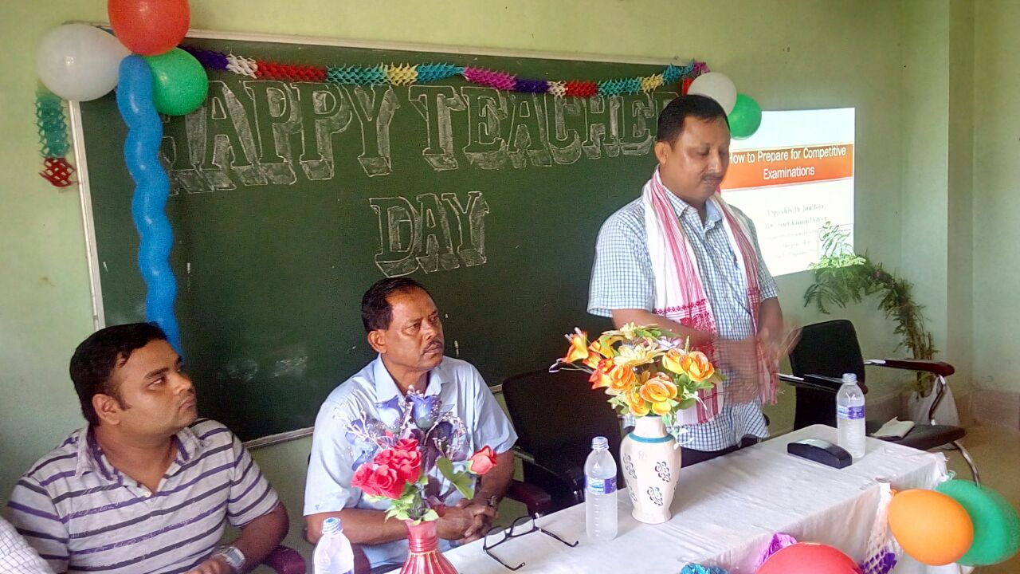
Deptt wall Magazine Competition 6th Spt 2019:



Workshop on Debate and & Symposium organized by Chhaygaon College Student Union:
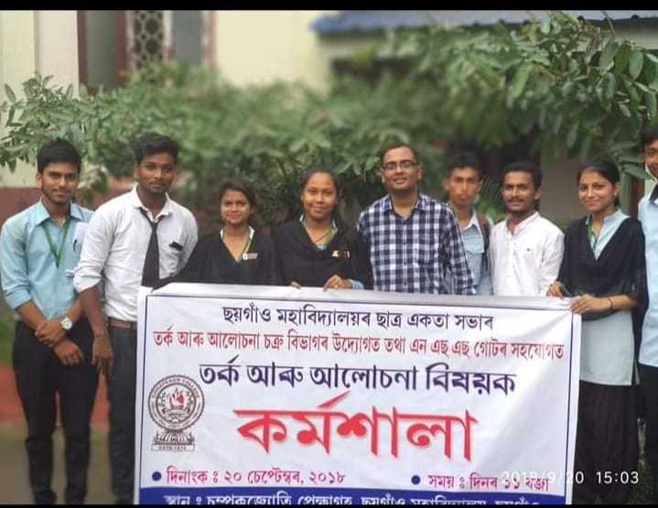

Health Checkup Camp 6 oct 2018:
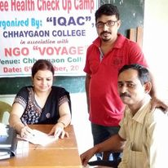

16 March 2019 Participation to Chhaygaon LokaUtsava:
