Report on the Orientation Programme on Introduction of the Fourth Year under FYUGP

Date: 29 June 2026
Time: 1:30 p.m.
Venue: Conference Hall, Chhaygaon College
No. of participants: 23
The IQAC, Chhaygaon College, organized an Orientation Programme on the Introduction of the Fourth Year under the Four-Year Undergraduate Programme (FYUGP) on 29 June 2026 at 1:30 p.m. in the Conference Hall of the college. The programme was attended exclusively by the teaching faculty of the college.
The programme was inaugurated by Dr. Naba Kumar Kalita, Principal, Chhaygaon College, who highlighted the significance of the fourth year under FYUGP in enhancing academic excellence, research orientation, and holistic development among students. He encouraged the faculty members to actively participate in the effective implementation of the new academic framework.
The resource person, Dr. Dilip Kumar Goswami, Assistant Professor, Department of Economics, Chhaygaon College, delivered a comprehensive presentation on the structure, objectives, and implementation of the fourth year under FYUGP. He explained the curriculum framework, research component, internship opportunities, credit requirements, and the academic and career prospects associated with the programme. The interactive session enabled the faculty members to clarify their queries regarding curriculum planning and implementation.
The programme concluded with a vote of thanks delivered by Dr. Lakhyadhar Sarma, IQAC Coordinator, Chhaygaon College, who expressed his gratitude to the Principal, the resource person, and all the faculty members for their active participation and valuable contributions towards the successful conduct of the programme.

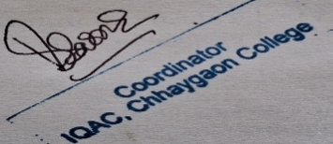
(Dr. Lakhyadhar Sarma)
IQAC Coordinator,
Chhaygaon College, Chhaygaon.
