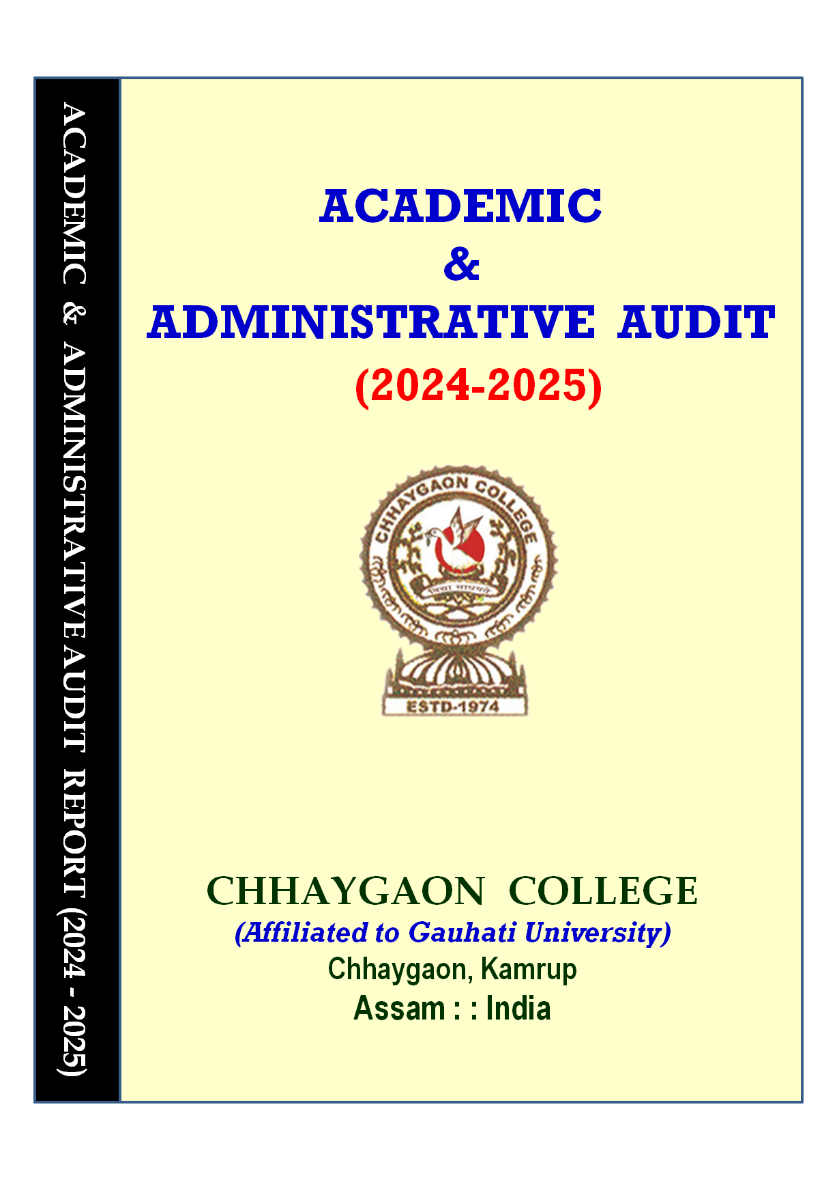

ACADEMIC & ADMINISTRATIVE AUDIT

REPORT
CHHAYGAON COLLEGE


INTRODUCTORY NOTE FROM THE AUDITORS
This report has been prepared by the undersigned members following a request from the authorities of Chhaygaon College to conduct an audit of the academic activities carried out during the academic session 2024–2025. The Academic and Administrative Audit (AAA) Report has been compiled based on the data submitted by the college, physical verification of records, and detailed interactions with faculty members and administrative personnel during our visit to the institution on the date mentioned below.
The IQAC Coordinator extended full cooperation and support throughout the audit process, facilitating departmental visits and coordinating departmental presentations. All academic departments presented their respective profiles through PowerPoint presentations, highlighting academic, co-curricular, and extension activities. These presentations were conducted in the conference room in the presence of the Principal and the IQAC Coordinator.
The findings presented in this report are based on the submitted documents, departmental verifications, office records, and interactions with the presenting teams of each department. The observations have been documented objectively in the form of facts and figures.

We solemnly declare that this report contains no statements or observations that may adversely affect or diminish the reputation of the college.
Members of the Academic Audit Team
PROF. DWIPEN BEZBARUAH
PROF. BHABEN TANTI

Visit Date: 12-12-2024
Session: 2024-2025

---::: Visit Schedule :::---

Members of the AAA | Date & Time | Agenda | Venue
Prof. Dwipen Bezbaruah  &  Prof. Bhaben Tanti | 12th December 2025  (10.00 am) | Academic & Administrative Audit for the Session 2024-25 | Conference Room
Prof. Dwipen Bezbaruah  &  Prof. Bhaben Tanti | 12th December 2025  (10.00 am) | Academic & Administrative Audit for the Session 2024-25 | Principal  Chhaygaon College
DEPARTMENTAL INTERACTION & HoD’S PRESENTATION

HOD, Assamese | 11.00 am | Departmental Presentation | Seminar Room
HOD, Economics | 11.15 am | Departmental Presentation | Seminar Room
HOD, Education | 11.30 am | Departmental Presentation | Meeting Room
HOD, English | 11.45 am | Departmental Presentation | Meeting Room
HOD, Hindi | 12.00 am | Departmental Presentation | Seminar Room
HOD, History | 12.15 am | Departmental Presentation | Seminar Room
HOD, Philosophy | 12.30 pm | Departmental Presentation | Seminar Room
HOD, Political Science | 12.45 pm | Departmental Presentation | Meeting Room
HOD, Accountancy | 1.00 pm | Departmental Presentation | Meeting Room
HOD, Banking | 1.15 pm | Departmental Presentation | Meeting Room
HOD, Business Mathematics and Statistics | 1.30 pm | Departmental Presentation | Meeting Room
HOD, Management | 1.45 pm | Departmental Presentation | Seminar Room
HOD, IT and Computer Application | 2.00 pm | Departmental Presentation | Seminar Room
Librarian | 3.00 pm | Library Presentation | Meeting Room
Office Staff | 3.45 pm | Interaction with the  Office Staff | Administrative Office
Exit Meeting | 4:30 pm | Interaction with the faculties and office staff | Auditorium

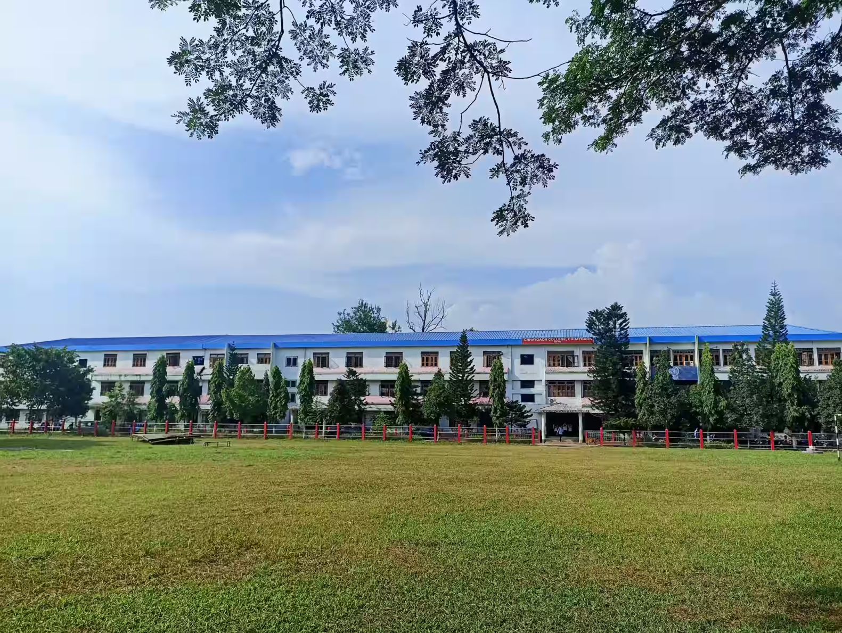

Profile of the Chhaygaon College

BRIEF INTRODUCTION OF THE COLLEGE

Chhaygaon College was established on 6 September 1974 at Chhaygaon in the Kamrup District of Assam with the objective of promoting higher education and nurturing leadership qualities among human resources to contribute meaningfully to the nation-building process. The college is situated on the bank of the perennial Kalahi River, adjacent to National Highway No. 17, approximately 35 km from Lokpriya Gopinath Bordoloi International Airport and about 40 km from Gauhati University.
The institution is spread over a vast area of lush greenery, surrounded by shady trees, providing a serene and conducive academic environment. Chhaygaon takes immense pride in its rich ethnic and cultural diversity and historical heritage, with landmarks such as Chandika Devalaya and Chanda Merghar standing as enduring testimonials to its legacy.
For the past five decades, Chhaygaon College has earned the trust of the community and has emerged as a premier institution offering holistic education to nearly 4,000 students from Chhaygaon and its surrounding regions, which are characterized by diverse racial and cultural backgrounds. The college has been assessed three times by NAAC and accredited with ‘B’ Grade in November 2004, 2015, and 2023. It is also recognized under Sections 2(f) and 12(B) of the UGC Act, 1956.
The Department of Assamese offers a Postgraduate programme affiliated with Gauhati University. In addition, the college provides career-oriented programmes such as PGDCA to enhance employability among young learners. The institution also offers Undergraduate and Postgraduate programmes under the aegis of KKHSOU and GUCDOE. Beyond conventional courses, the college offers vocational programmes in Information Technology, Computer Applications for Self-Employment, and Entrepreneurship Development.
The dedicated faculty and proactive management leave no stone unturned in nurturing the academic, professional, and personal potential of students. Over the last 50 years, Chhaygaon College has successfully fostered a vibrant academic culture and has significantly contributed to higher education in the region.
The emblem of the college has been designed in a circular form, resting on a raised base with four pillars positioned at each corner. The circular shape symbolizes motion, prosperity, and continuity. The background, encircled by a red sun, represents the hope of light and knowledge. The sun is flanked on both sides by two leafy branches, signifying growth and vitality. In front of the sun, a bird in flight carrying food in its beak has been depicted, symbolizing the struggle for existence and the pursuit of knowledge. Just below the sun, two Sanskrit words — “Bidya Sadhoyote”, have been inscribed, meaning “knowledge is power,” emphasizing that knowledge is the ultimate means to achieve the institution’s goals and objectives. The year of establishment of the college has been engraved at the lower front portion of the emblem, marking the beginning of higher and quality education in the greater Chhaygaon area.

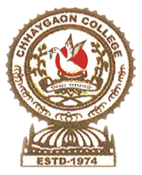

Organogram of the Institute

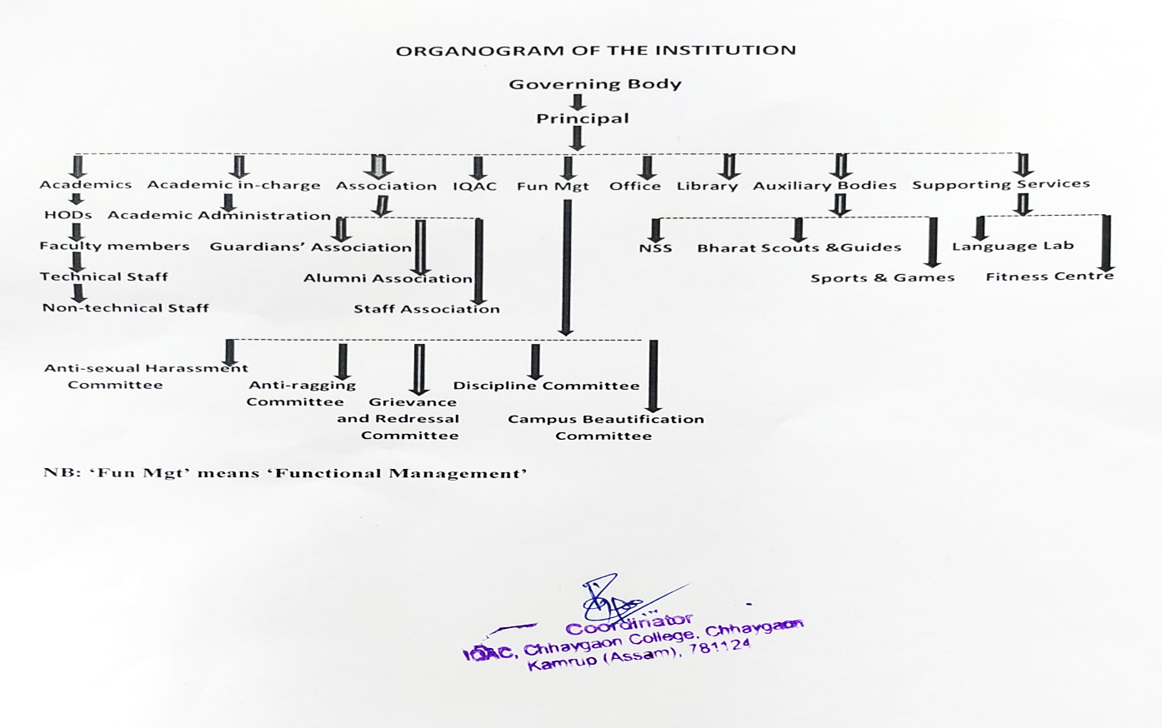

Vision and Mission

- VISION
The vision of the institution is to provide excellent educational opportunities to empower students to contribute to the transformation of society by encouraging and molding them to be socially conscious and responsible. We seek to achieve our educational vision by creating an academic environment where the intellectual, cultural, social, physical, and recreational needs of the students are met.

- Offering a learning platform where students come together to challenge one another's ideas in an atmosphere of mutual respect.
- Providing extensive field experience to bring together theory and practice.
- Proving social service to the larger community of the area as well as ensuring faculty, administration, and student participation in community programs.

- MISSION
To provide the students with knowledge, skills, values, and sensitivity to face the challenges in life both in the academic field and in social and private lives. The college aims at providing high-quality education and cutting-edge areas leading to the creation of a college where innovation, invention, and entrepreneurship remain the cordial focus and thrust. The college strives to prepare the students to face the challenges encountered in a competitive environment. The mission of the institution is as follows:
- To impart quality higher education and educational innovations for academic excellence.
- To provide opportunities for the students to develop their personalities through community.
- To promote an awareness and understanding of society and its numerous problems among the students.
- To attempt to evolve strategies for guiding and counseling students for self-employment and entrepreneurship development.
- To provide a forum for interaction and exchange of views among the teachers and students by organizing seminars, conferences, workshops, etc.
- To equip the students to lead social life happily in peace and harmony.
- To utilize the different resources and facilities available in and around the institution to maintain the quality of the academic and other aspects of campus life for the benefit of the staff and the students.
- To encourage national integration by undertaking different socio-cultural activities. Besides, the college seeks to see how the students and teachers benefit from each other.

- NUMBER OF STREAMS: 02 (Arts and Commerce)

- NUMBER OF SUBJECTS: 13 (Assamese, Economics, Education, English, Hindi, History, Philosophy, Political Science, Accountancy, Banking, Business Mathematics and Statistics, Management, IT and Computer Application)

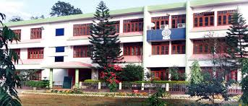

INFRASTRUCTURE FACILITIES OF THE COLLEGE

Facilities | 2024-25
Campus area | 10.38 Acres
Built up area | 6.82 Acre
Class rooms | 38
Smart Class Room | 5
Campus Wi-Fi | YES (20 no. of Airtel Broadband connection; 3 connections with 20 connected points with 100 MBPS)
Language Lab. | 1
Laboratories | 2
Total number of text books and reference books available for UG and PG | 28892
Seminar/Conference Halls | 5
Meeting Room | 1
Auditorium | 1
Water Supply Plant | 1
Water Treatment Plant | 1
Parking place | 3
Teachers’ Common Room | 1
Museum | 1
Girl’s Common Room | 1
Boy’s Common Room | 1
College Canteen | 2
Boundary wall | YES
Total Computer | 74
Students Browsing Centre | 1
Computer lab | 1 common computer center
Outdoor sports Ground | 1
Badminton Court | 1
Basketball court | 1
Gymnasium Hall | 1
Yoga and Wellness Centre | 1
Volleyball Court | 1
Women Hostel | 1
Indoor Sports Complex | 1
College Press | 1
Examination Control Room | 2
Distance Education Centre (Study Centre of KKH State Open University, GUCDOE) | 1 each

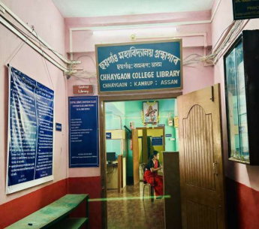


Academic Strength

Name of the Department | UG/PG & Intake | Number of Teachers
Assamese | UG (185) & PG (30) | 4
Economics | UG (90) | 5
Education | UG (120) | 3
English | UG (120) | 5
Hindi | UG (180) | 3
History | UG (90) | 2
Philosophy | UG (90) | 3
Political Science | UG (180) | 6
Accountancy | UG (200) | 3
Banking | UG (200) | 3
Business Mathematics and Statistics | UG (200) | 2
Management | UG (200) | 4
IT and Computer Application | UG (250) | 2

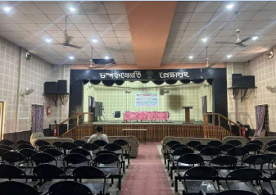


Methodology of Audit

The inputs received from the departments as per the proforma (Annexure-1) have been validated from the supporting documents, interaction with the Head of the Department, and visits to the departments.

Curricular Aspects
Chhaygaon College, Chhaygaon is affiliated with Gauhati University. The College follows the curriculum developed by Gauhati University. For effective delivery of curriculum, the departments are maintaining lesson plans and course progress records. Departments follow the academic calendar of Gauhati University and the college has its own in alignment with Gauhati University’s calendar.

Teaching Learning Aspects
Assessment of learning levels to identify slow and advanced learners is carried out through sessional examination, seminars, and assignments. Though the College follows students’ centric learning method for effective curriculum delivery, however, a detailed unit-wise plan for experiential and participative learning needs to be maintained for enhancing the learning experiences of the students. The College maintains a mentoring system. All the departments conduct internal examinations as per the requirement of the affiliating University. The College may incorporate more different modes for continuous internal evaluation.
Program Outcomes, Program Specific Outcomes, and Course Outcomes are described in the syllabus. Evaluation of the attainment of the learning outcomes to be evaluated properly.

Research, Innovation, and Extension
The college has recently started various research activities. However, the overall research culture in the College needs to be strengthened. Several departments are conducting very effective extension activities. The involvement of the students in those activities should be encouraged.

Infrastructure
The College has adequate infrastructure facilities for all academic and other extracurricular activities. The indoor and outdoor play area is adequate. The library and IT facilities need to be improved including increased internet bandwidth.

Student Support and Progression
Several Departments conduct capacity-building and skill enhancement activities for the students. The placement of the students and progression to higher education is encouraging. Students need more encouragement for participation in extra- curricular activities.

Professional Development Activities
A few teachers have participated in FDP. But more teachers need to be participated in FDPs.
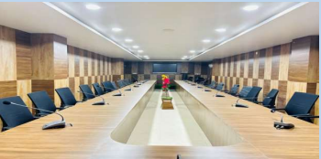

SWOC Analysis


Strength of the Institution

- The biggest strength of our institution is that each and every member of our family feels proud being a member of this august institution.
- There is an eco-friendly atmosphere in the college. The college campus is surrounded by green trees which fill up the campus with fresh air. The students enjoy relaxing under the shades of trees.
- Although, the College is situated in rural area, it is not a problem at all, so far communication is concerned. Because, the NH No. 17 is passed by the southern side of the College. Further, it is simply 25 K.M. away from LGB international airport and 35 K.M. from Gauhati University.
- The college has an inclusive institutional environment that encourages diversity.
- The college provides undergraduate and postgraduate programme of study along with the provision of Open Education through KKHSOU and GUCDOE, Gauhati university.
- All round personality development of the students is desired by encouraging and involving them in different types of co-curricular activities. In literary, cultural and sports sections, the performance of the students in inters- college level, state level and national level is satisfactory and appreciable.
- The College has a very strong Governing Body, comprising of renowned personalities from different fields of activities. It follows decentralisation and transparency in administration.
- There is a cordial student-teacher relationship in the institution and the students’ unions of the College is always ready to extend their helping hand for the smooth conduct and functioning of the institution.


Weakness of the Institute

- Limited area of land hampering the expansion of college campus as well as the growth of physical infrastructure for outdoor sports activities.
- Another weakness of the college is insufficient teaching and non-teaching staff. There is shortage of permanent teaching staff in some of the departments.
- Limited resources in the use of digital technology to enhance teaching learning on campus.
- Infrastructural obstacles in the introduction of new courses and programs of study.
- Most of the students hail from vernacular medium schools. So, there is lack of communication skill among the students.
- The number of teachers is not sufficient to balance the students-teacher ratio. 7. Lack of science stream to facilitate local students.


Opportunities
- The college has signed MOU with industrial units, NGO and nearby college so that our students get more employment opportunities as well as overall development.
- As the college situated in a rural area, raw materials like orange, pineapple, banana etc. are available in abundant in Chhaygaon and surrounding areas. Therefore, ample opportunities are there to introduce some courses related to an agriculture (for instance courses like food processing, horticulture, sericulture, fishery etc.).
- To open Post Graduate classes in some selected departments.
- To encourage research and extension activities in the field of culture, natural resources and its utilization. The Chhaygaon area is famous for export quality Eri product. Therefore, there is very good opportunity for the development of the handloom sector by which the students and the others earn their livelihood.

- The maximum number of the students hails from rural area having SC/ST/OBC/MOBC/Minority background. There are ample scopes for developing these sections.
Challenges

- Meeting resource constraints in maintaining preparedness in the rapidly changing higher education scenario.
- Overloading of works of teaching and non-teaching staff.
- More than 2,000 students in Higher Secondary level create a burden for the limited number of faculties and the same restricts concentration on the UG and PG courses.
- Ensuring better placement opportunities for the students.
- Due to poor economic background of the families in the locality, it is difficult to open self-financed job-oriented courses.
- Ensuring adequate availability of funds for the maintenance of an ageing physical infrastructure and renewal of campus facility.
- To meet the multidimensional objectives and aspects of NEP.

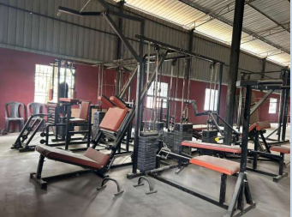

Recommendations

- A few larger classrooms with ICT facilities need to be created to conduct common courses under the FYUGP.
- The college needs to develop a structured methodology for identifying slow learners and implementing appropriate remedial measures for their improvement.
- The college may arrange a motivational lecture and/or counseling session for all freshers at the beginning of the academic session.
- Teachers may be encouraged to enhance their research output, fund mobilization, and consultancy services. To this end, the Principal may arrange periodic brainstorming sessions with faculty members to gather their inputs and formulate strategies for improving research productivity.
- The research culture needs significant improvement, and interdisciplinary research initiatives should be promoted.
- For effective curriculum delivery, course files of academic departments should be assessed periodically by the IQAC.
- The college should take initiatives to organize National and/or International level seminars, workshops, or conferences with multidisciplinary themes.
- Greater involvement of departments and students is required in extension and outreach activities.
- More teachers should be encouraged to participate in FIP/FDP programmes.
10. Proper and systematic documentation should be maintained for all academic and administrative activities.
- Best practices of individual departments should be identified and institutionalized. Additionally, two institutional best practices need to be restructured in accordance with NAAC guidelines.
- Students and society should be actively engaged while formulating policies related to student welfare and community development.
- More collaborations should be established for faculty exchange, student exchange, internships, and related academic activities.
- A master list of all office-related documents, including document numbers, retention periods, SOPs, and vendor feedback, should be properly maintained.
- Certification from the District Public Health Engineering (PHE) Department should be displayed at the common drinking water facility.
- Safety measures such as installation of fire extinguishers in selected locations and clear markings for emergency exits in multistoried buildings should be ensured.

Name of the Members of the Audit | Signature
Prof. Dwipen Bezbaruah
Professor, Department of Anthropology
Gauhati University
Prof. Bhaben Tanti
Professor, Department of Botany
Gauhati University

